

SCHOOL OF COMPUTING AND ENGINEERING SCIENCES

  - BACHELOR OF SCIENCE IN ELECTRICAL AND ELECTRONICS ENGINEERING(BSEEE)

  - Network theory lab one report

BY
NAME | ADM.NO
ANDRIAN ACHIENG’
ANDREW NZIOKI
EDWARD ARIBU | 142092
IVY WACEKE | 145338

SUPERVISOR: Jamlick Ntonjira

DATE:22nd September 2022

Table of Contents
ABSTRACT 3
OBJECTIVE 3
THEORETICAL ANALYSIS 4
GRAPH REPRESENTING CHARGING AND DISCHARGING OF A CAPACITOR 7
APPARATUS 8
PROCEDURE 8
RESULTS AND DISCUSSIONS 9
BIBLIOGRAPHY. 10

ABSTRACT

There was one experiment conducted which was testing the charging and discharging of a capacitor. In this experiment a capacitor is charged and discharged, and the time taken is recorded at equal intervals.

OBJECTIVE
The objective of this experiment was to investigate the charging and the discharging of a capacitor with respect to time.

THEORETICAL ANALYSIS
resistors
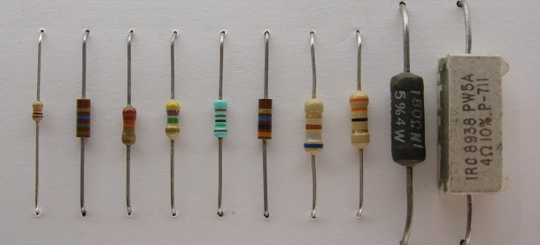
Figure 1
A resistor is defined as a passive electrical component that has two terminals and hinders the current flow through it. It was discovered back in 1900s. A resistor is an electrical component whose task is to restrict the current flow and drop the voltage within the particular circuit. They are usually color coded instead of a numerical value for their power rating.(Engineer, 2014)

capacitors
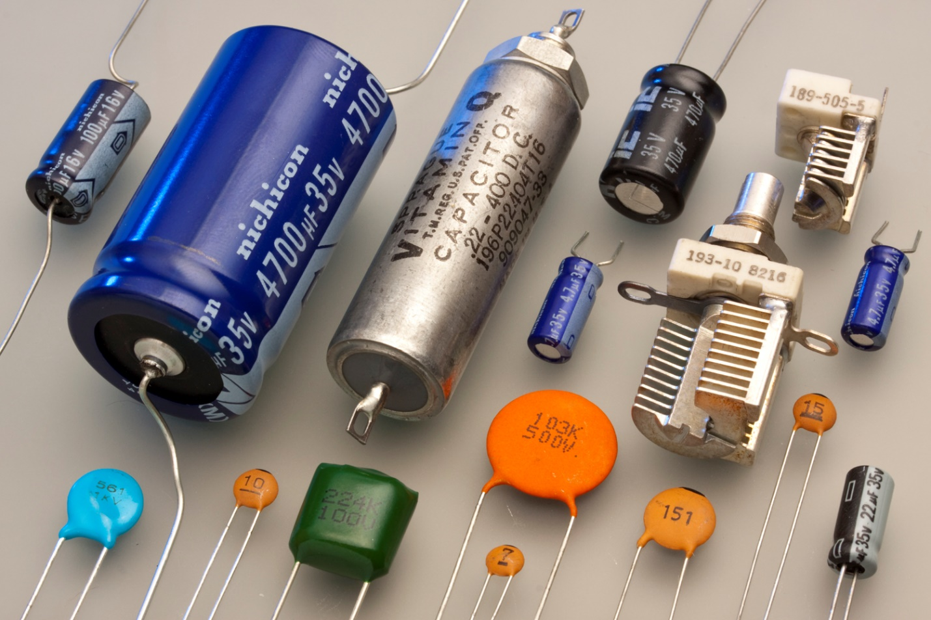
Figure 2
(“Capacitor,” 2022)
A capacitor is one of several types of devices that are used in the electric circuits of radios, computers, and other similar devices. Capacitors temporarily store energy in circuits and can be programmed to release it when needed. The capacitance of a capacitor is the property that characterizes its ability to store energy.
An electric field exists within a capacitor when energy is stored in it. The stored energy can be linked to an electric field. Energy is indeed associated with the presence of an electric field. The study of capacitors and capacitance leads us to an important aspect of electric fields: field energy.
During charging, electrons flow from the power supply's negative terminal to one plate of the capacitor and from the other plate to the power supply's positive terminal.
When the switch is closed and charging begins, the rate of charge flow is high (i.e. a large current), and this decreases over time as the plates become more charged, "resisting" further charging. You should understand that adding a resistor in series with the capacitor only affects the TIME it takes for the capacitor to fully charge, not the EVENTUAL POTENTIAL DIFFERENCE ACROSS IT - which is always the same and equal to the potential difference
As soon as the switch is open a ‘large’ current starts to flow and the potential difference across the capacitor drops. (Figure 4). As charge flows from one plate to the other through the resistor the charge is neutralized and so the current falls and the rate of decrease of potential difference also falls.
When the switch is turned off during discharging, a 'large' current begins to flow, and the potential difference across the capacitor decreases. As charge flows from one plate to the other through the resistor, the charge is neutralized, causing the current to fall and the rate of potential difference decrease to fall as well.

When the charge on the plates reaches zero, as well as the current and potential difference, the capacitor is fully discharged. It is important to note that the resistor value has no effect on the final potential difference across the capacitor, only the time it takes to reach that value.

The larger the resistor, the longer the time required.

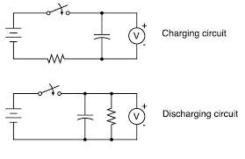
Figure 3
The following are formulas in finding the charge in the capacitor:
Q=C*V
τ = R x C
τ-represents the time constant

GRAPH REPRESENTING CHARGING AND DISCHARGING OF A CAPACITOR
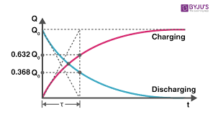
Figure 4

APPARATUS
- Power supply
- Capacitor
- Resistor
- Voltmeter
- Stopwatch

PROCEDURE
- Construct the circuit as shown below in the figure.
- In the first case when the switch is placed in position A the charge flows from the battery into the capacitor until it is fully charged.
- In the second case the switch was placed at B the capacitor discharges through the resistor.
- Repeat the procedure ten times to obtain a minimum of ten values of voltages and their corresponding time in each case and tabulate them.
- The ammeter was connected in series with the capacitor and resistor.

RESULTS AND DISCUSSIONS
TABLE 1: Charging of a capacitor
Item No. | Time(seconds) | Voltage Vc | Current Ic
1. | 25.00 | 18.30
2. | 50.00 | 22.30
3. | 75.00 | 23.40
4. | 100.00 | 23.80

TABLE 2: Discharging of a capacitor
Item No. | Time(seconds) | Voltage Vc | Current Ic
1. | 10.00 | 18.00
2. | 20.00 | 12.80
3. | 30.00 | 8.70
4. | 40.00 | 5.80

BIBLIOGRAPHY.
Capacitor. (2022). In Wikipedia. https://en.wikipedia.org/w/index.php?title=Capacitor&oldid=1110460722
Engineer, T. (2014, June 24). What Is A Resistor? Wonderful Engineering. https://wonderfulengineering.com/what-is-a-resistor/

